$$\frac{1}{4}$$ | $$\frac{1}{2}$$ | $$\frac{7}{8}$$ | $$\frac{10}{16}$$
$$\frac{3}{8}$$ | $$\frac{16}{16}$$ | $$\frac{3}{4}$$ | $$\frac{1}{8}$$
Sheet 1
$$\frac{39}{40}$$ | $$\frac{1}{4}$$ | $$\frac{1}{8}$$ | $$\frac{3}{5}$$
$$\frac{18}{20}$$ | $$\frac{1}{2}$$ | $$\frac{1}{5}$$ | $$\frac{1}{10}$$
Sheet 2
$$\frac{1}{5}$$ | $$\frac{4}{5}$$ | 10% | $$\frac{3}{4}$$
60% | $$\frac{9}{20}$$ | 25% | $$\frac{3}{10}$$
Sheet 3
$$\frac{6}{10}$$ | $$\frac{1}{4}$$ | $$\frac{29}{30}$$ | $$\frac{1}{5}$$
$$\frac{15}{20}$$ | $$\frac{11}{12}$$ | $$\frac{1}{3}$$ | $$\frac{1}{12}$$
Sheet 4
$$\frac{1}{20}$$ | 0.09 | 99% | $$\frac{3}{5}$$
18% | $$\frac{2}{25}$$ | 0.2 | $$\frac{1}{10}$$
Sheet 5
$$\frac{3}{16}$$ | $$\frac{1}{2}$$ |  | 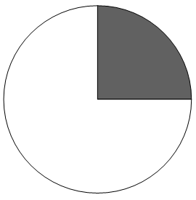
 | $$\frac{15}{16}$$ | 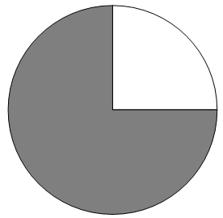 | $$\frac{5}{32}$$
Sheet 6

